KASHIPUR MICHAEL MADHUSUDAN MAHAVIDYALAYA

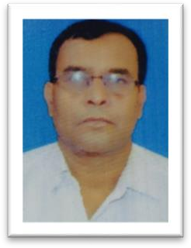

PERSONAL PROFILE

Name: AMIYA KUAMR MUKHERJEE
Designation: STATE AIDED COLLEGE TEACHER
Date of Joining: 31-08-2002
E-mail: amiosir444@gmail.com

Educational Qualification:

1. M.A. in Sociology

Work Experience – 18+ Years:

1. KASHIPUR M.M.Mahavidyalaya 31-08-2002 to till date.

National/International Conferences/Seminars/Workshops Attended:

Paper Presentation
1. National Seminar on Purushartha in Mahabharata and Modern Life on 20-05-2015 organized by Philosophy and Sanskrit, SKBU Purulia.

Participation
- UGC sponsored National Seminar on “CHALLENGES OF COMMON PROPERTY RESOURCES” held on
22-23rd September, 2011 organized by the department of Economics in Kashipur Michael Madhusudan Mahavidyalaya, Purulia, West Bengal, India.

- One day Seminar-cum-workshop on “Other Cultures : Connotations and Contestations” held on
1st October, 2015 organized by the department of Sociology, Kashipur Michael Madhusudan Mahavidyalaya, Purulia, West Bengal, India.

- One day State level Seminar on “System of Subjection: The Individual in Modern Regimes of Power” Held on 23rd Sept., 2015 organized by the department of Sociology, Kashipur Michael Madhusudan Mahavidyalaya, Purulia, West Bengal, India.

- 11th Occasional Lecture - on the theme of “Visual Sociology” held on 27th April, 2015 organized by The department of Sociology, SKBU, Purulia, West Bengal, India.
- ICSSR Sponsored One day international seminar on “Media, Society and Culture: Interrelation And Changing Scenario” held on 25-26th Feb, 2020 organized by the department of Sociology, Kashipur Michael Madhusudan Mahavidyalaya, Purulia, West Bengal, India.

Training Programmes: NA

List of Research Papers published in National/International Journals/Books/Conference Proceedings: NA

Areas of Specialization/Research/Teaching: NA.

Teaching:

  - Theory
    - First year Hons. & Pass
    - Second year Hons. & Pass
    - Third year Hons. & Pass
  - Practical: NA.

